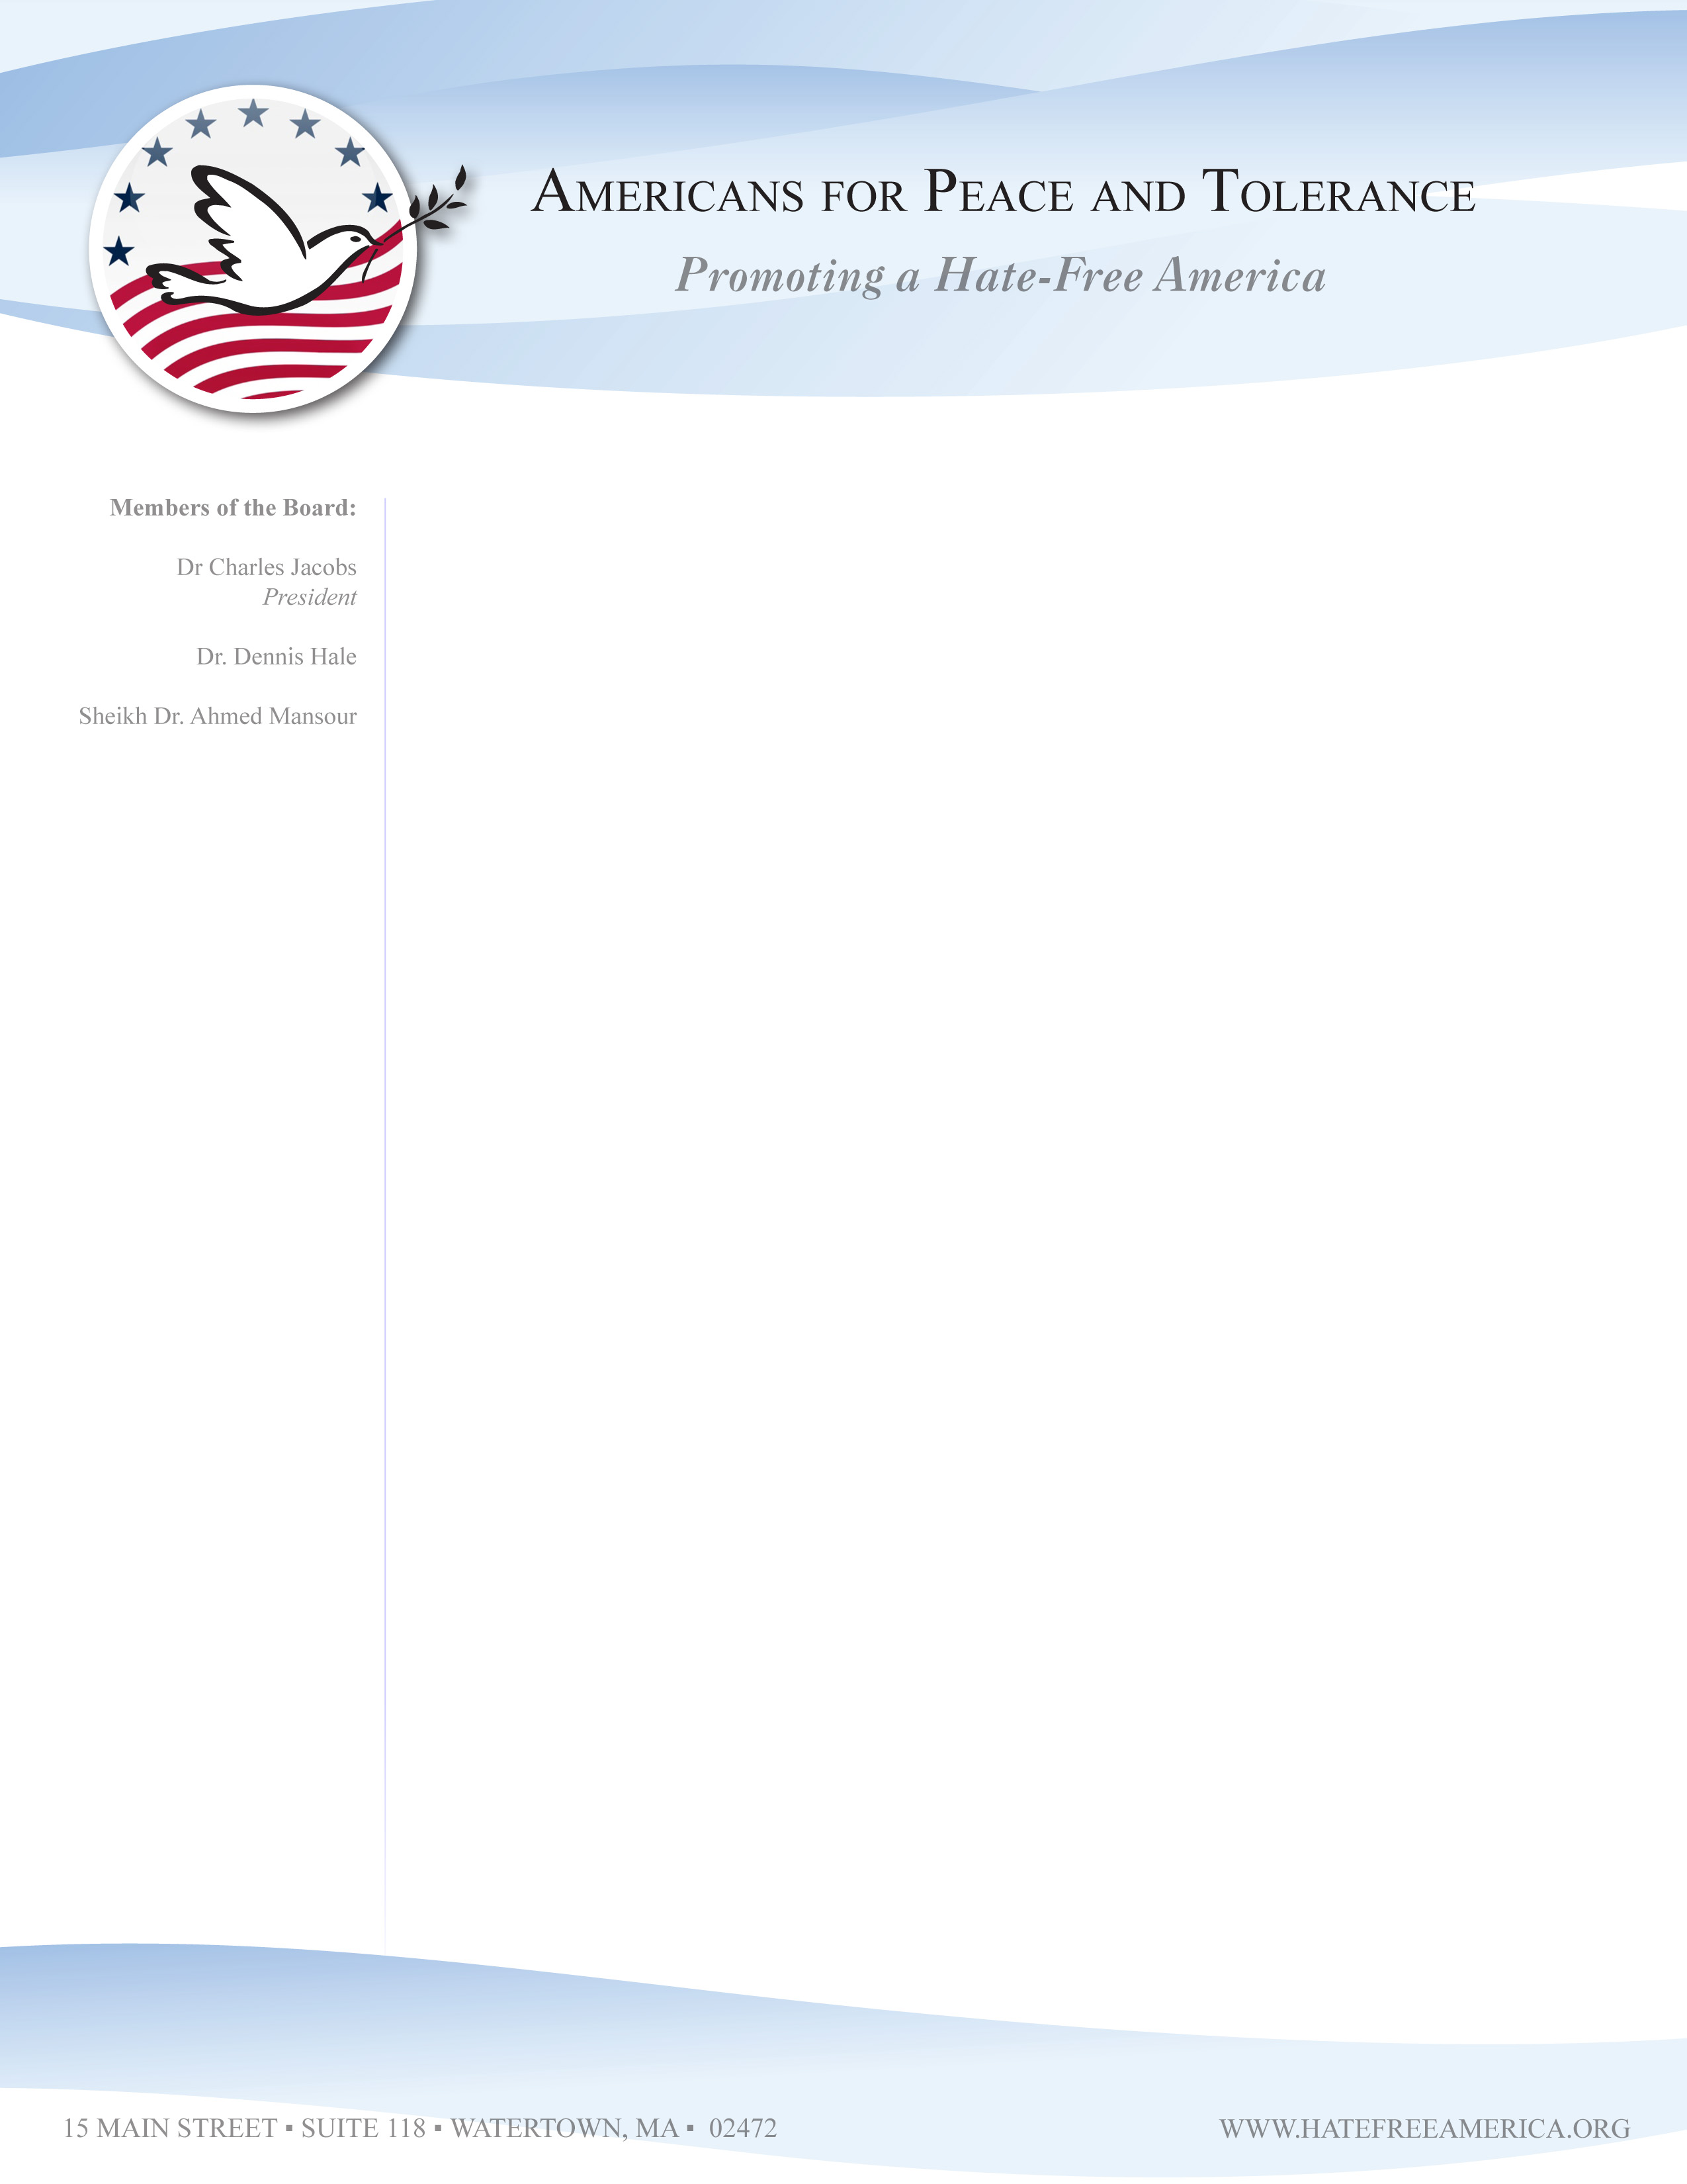
Media Alert

WHAT: Press Conference to Caution about Extremist Leadership of the Boston Islamic Center.

WHEN: Thursday, June 25th, 10:30 AM

WHERE: Sheraton Crowne Plaza Hotel Newton, 320 Washington Street, Newton, MA 02158. (617)969-3010.

WHY: Gov. Patrick and Mayor Menino are about to embrace extremist leaders of an Islamic cultural center linked to the radical Muslim Brotherhood organization.

Background:

On Friday, June 26th, city and state officials will participate in the opening of the Islamic Society of Boston’s Cultural Center (ISBCC) in Roxbury, MA.

But at the June 25th Press Conference, Americans for Peace and Tolerance will release new documentation and information about:
- The real ownership and funding of the ISBCC
- The ISBCC leaders’ radical organizational connections and hateful ideology, and
- Anti-Christian and anti-Jewish sermons

The ISBCC is now controlled by the Muslim American Society (MAS). U.S. Federal prosecutors have identified the MAS as, “The overt arm of the Muslim Brotherhood in America.”

It is essential to distinguish between the moderate Muslim community of Boston and the extremist and well-funded leadership of the ISBCC.
We call upon Governor Patrick and Mayor Menino to reject the extremist leadership of the ISBCC while continuing to reach out to the moderate Muslim community in Boston.
Americans for Peace and Tolerance (APT) is a Boston-based 501(c)(3) non-profit organization dedicated to promoting peaceful coexistence in an ethnically diverse America.. We are concerned citizens, academics, and community activists. As Christians, Jews, and Muslims, we believe peaceful coexistence among diverse ethnic populations is only possible if we all promote a climate of tolerance and civil society.
For more information, contact Dr. Charles Jacobs at 617-869-1202.

